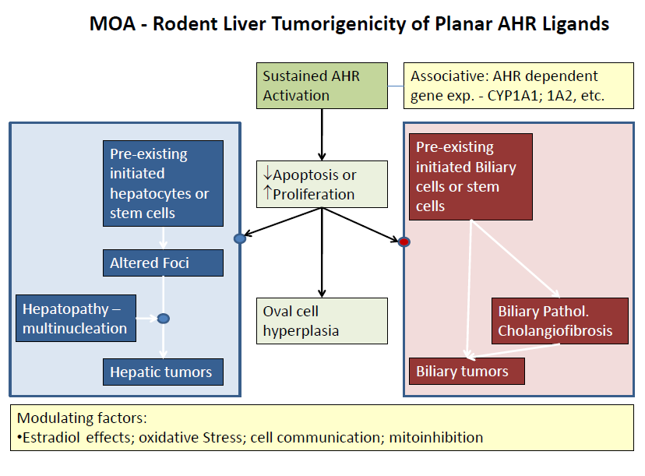

Figure 1. Mode of Action for Rodent Liver Tumorigenicity of Planar AHR ligands such as TCDD.

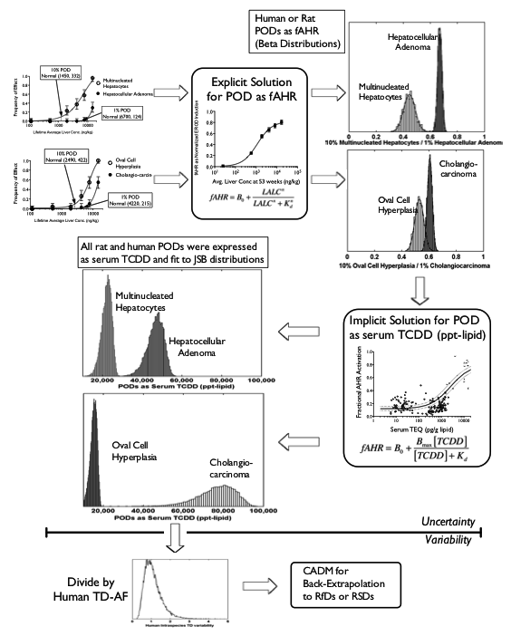
Figure 2. Flow Chart for Conceptual Model 2 for rat endpoints

Figure 3. Flow Chart for Conceptual Model 2 for human endpoints

Figure 4. Preliminary Results

